**IOT Based Comatose Patient Monitoring System With PHP Webserver Using Raspberry**. (Android)

**Project Requirements**

**Aim:**

In the present world, IoT is changing the infrastructure of technologies.  By facilitating effortless interaction among various modules, IoT has enabled us to implement various complex systems. We typically think of the Internet of things (IoT) in terms of autonomous cars and smart homes, but some of the best applications of IoT technology are in fields that are intensely practical.  Health monitoring systems are one of the most notable applications of IoT. In this paper, a review of IOT Based Comatose Patient Monitoring System with PHP Webserver Using Raspberrypi. (Android) is presented. As we know coma is a state of unconsciousness in which patient cannot feel or respond to the pain, light or sound. Patients in a coma state need to have a continuous update of Blood pressure, temperature, Pulse rate, and urine level. Doing this manually can become almost impossible to keep updates of multiple patients at the same time. In order to address this situation, our system comes to the rescue; this system will collect the information of patients & update the values to cloud with the help of sensors. These data can be visualized by using mobile app.

**Hardware & Software Requirements:**

1. RASPBERRY PI
2. EMBEDDED C
3. PHP 7
4. HTML5
5. CSS 3
6. BOOT STRAP
7. AJAX
8. MY SQL
9. J QUERY
10. ECG SENSOR
11. PULSE RATE SENSOR
12. TEMPERATURE SENSOR
13. BUZZER
14. POWER SUPPLY
15. TRANSFORMER
16. 5V ADAPTER
17. LCD
18. GLUCO METER
19. URINE LEVEL INDICATOR
20. MOBILE APP
    1. **PROJECT FLOW:**

Lcd

URINE LEVEL INDICATOR

raspberrypi

Cloud

TEMPERATURE SENSOR

ECG SENSOR

PULSE RATE SENSOR

Buzzer

URINE LEVEL INDICATOR

MOBILE APP

GLUCO METER

Power supply

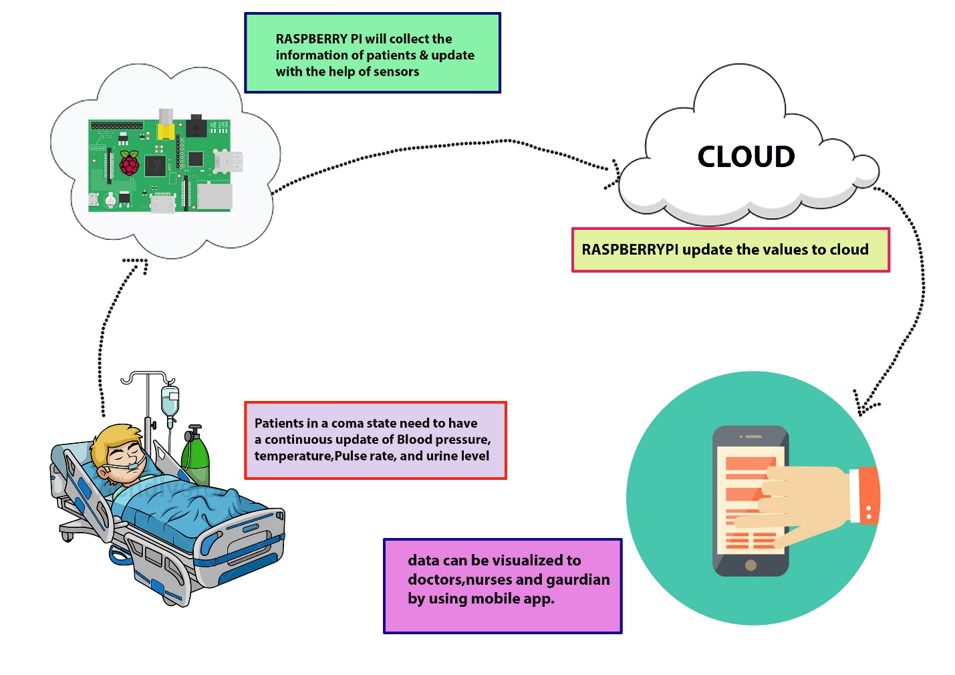

**Dashboard:**

**Mobile app dashboard**

1. In mobile app each patient have separate id and separate dashboard
2. The data from raspberry pi will stores in server and helps to check anytime
3. Data will display in app that coming from system in real time
4. Mobile app will alert admin/Data entry, doctors, nurses, Guardian If any emergency situation will occurs

**ADMIN/Data entry:**

1. When coma patient admitted to hospital admin/data entry operator will enters the data of the patient like name, age, and gender, any previous diseases, previous health history etc….
2. Data entry person will gives particular ID to the each individual patient.
3. These data will be visual to doctor, nurse, patient guardian...

**DOCTORS:**

1. It’s very difficult to monitor every patient individually to doctors.
2. By using this app doctor can check their present health condition of the every patient easy
3. Doctor can react immediately when the patients’ health situation will changes
4. Doctor can also suggest to nurses about prescriptions, medicines that patient needs through this app
5. If any emergency situation will doctor can assists the nurse to take care about patient when he is not available

**NURSE:**

1. Nurse will check the data of every patient and follows the instructions that given by the doctor through app
2. Nurse will also update the present situation of the patient to doctor/guardian of patient
3. Nurse can also warn doctor/guardian immediately if anything happens through single emergency button

**PATIENT GAURDIAN:**

1. Guardian can check the data of patient any time, any where
2. Guardian can warn doctor/nurse immediately if anything happens through single emergency button